Language learning websites

Definition:
# Source: AI Source: Provided by: [Data Path: Persons Table -> ID Column: 1, Name_En Column: Motasem Essam] -> From: [Chatgpt (GPT‑5 Mini)] on [2/12/2026]
Language learning websites are websites or web apps designed specifically to help people learn new languages online, often through lessons, exercises, and interactive tools.

Simple Definition
# Source: AI Source: Provided by: [Data Path: Persons Table -> ID Column: 1, Name_En Column: Motasem Essam] -> From: [Chatgpt (GPT‑5 Mini)] on [2/12/2026]
Language learning website = an online platform to learn, practice, and improve a language.

What Language Learning Websites Usually Include
# Source: AI Source: Provided by: [Data Path: Persons Table -> ID Column: 1, Name_En Column: Motasem Essam] -> From: [Chatgpt (GPT‑5 Mini)] on [2/12/2026]
- Lessons & Tutorials – reading, writing, speaking, and listening exercises
- Quizzes & Practice Tests – assess understanding and progress
- Gamification / Rewards – points, badges, levels to motivate learners
- Interactive Exercises – speaking, listening, or matching games
- Progress Tracking – monitor your improvement over time
- Community / Forums – practice with other learners

Examples of Language Learning Websites
# Source: AI Source: Provided by: [Data Path: Persons Table -> ID Column: 1, Name_En Column: Motasem Essam] -> From: [Chatgpt (GPT‑5 Mini)] on [2/12/2026]
- Duolingo – gamified language learning
- Babbel – structured lessons for different languages
- Busuu – practice with native speakers
- Rosetta Stone – immersive language courses

Purpose of Language Learning Websites
# Source: AI Source: Provided by: [Data Path: Persons Table -> ID Column: 1, Name_En Column: Motasem Essam] -> From: [Chatgpt (GPT‑5 Mini)] on [2/12/2026]
- Make language learning flexible and accessible anywhere
- Provide interactive and fun learning methods
- Allow learners to practice and test themselves
- Track progress and achievements
- Connect learners with native speakers or communities

Difference from Other Educational Websites
# Source: AI Source: Provided by: [Data Path: Persons Table -> ID Column: 1, Name_En Column: Motasem Essam] -> From: [Chatgpt (GPT‑5 Mini)] on [2/12/2026]
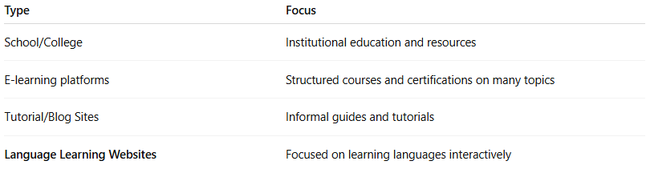
Type | Focus
School/College | Institutional education and resources
E-learning platforms | Structured courses and certifications on many topics
Tutorial/Blog Sites | Informal guides and tutorials
Language Learning Websites | Focused on learning languages interactively

